# Conventional Ovens

It is true that conventional oven cook or heat food better than microwaves. The food tastes better and the heat is spread evenly across the food. But one of the main disadvantages of using a conventional oven is the wait time. The total time to cook or heat the food includes the pre-heating time and the actual time it takes to heat the food. What takes 3 minutes in a microwave to heat, takes 15 – 20 minutes in the conventional oven. On a tiring day, we usually go for the microwave because it’s faster. There are a few attempts to make the conventional ovens smarter and accessible from anywhere. But a brief explanation about how ovens have improved over the years is important to see the advancements.

## History of Conventional Ovens.

Wood Burning Ovens - The initial ovens were made by burning wood and the food is cooked with the increase in temperature caused by the wood. Disadvantages of this includes excessive heat for the person making the food and temperature cannot be controlled very easily.

Iron stoves – They were an improvement to Wood burning stoves in the sense that humans did not have to directly come in contact with a lot of heat. These stoves also had wood but the advantage was that you could adjust the temperatures of individual pots easily.

Electronic Ovens – Fast forward a few years and we now have the electronic ovens that can be controlled by switches or buttons. These are relatively easy to use then the previous methods and take less effort to pre-heat the oven.

One thing that changed drastically in all these ovens are the way they are controlled. The old conventional ovens will have different instruments to place or move wood. The move recent ovens use buttons or switches to interact. The older ovens did not give out any signals just as if the desired temperature has been attained. The user will have to use other equipment, his/her own guess or time frame to check if the temperature is attained. This can often be difficult and prone to errors. In the modern ovens, when the desired temperature is attained, a visual indication such as a light blinking and a sound is used. This catches the user’s attention and the user knows that the oven is pre-heated for sure. Even if he forgets to check the oven, the temperature in the oven will stabilize in the required temperature unlike the old ovens where the temperature can keep increasing and reduce when the wood is over if there is no user intervention.

The way we operate these ovens have also changed throughout the years. We have moved from analog, to digital and now, towards smartphones apps to control the temperature of the oven even if we are not at home. There are pros and cons to each of them –

## Analog Interface –

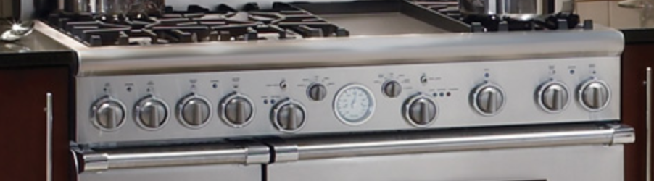

Figure - Analog dials to control oven and stove temperatures

### Pros

* The analog interface is easy first time use.
* Also analog dials allow the user to see exactly where he is in the range of selection. The users already know the min and max value of the oven and set the temperature appropriately.
* Some analog dials show the red/green range to notify you when you going towards really hot temperatures.
* It is easy to set the temperature to the correct value. For example, if we wanted to set the oven to 205 degrees, it’s easy to approximate the value. But this depends on the range values between the two values in the dial.

### Cons

* Sometimes, these analog dials do not have child safe locks. So, children can easily on the oven which can be dangerous if left unattended.
* If there are stoves on top of an oven, there are many dials and if the interface is poorly dialed, users will always have to think or see the instructions about which dial is for which.
* Sometimes there is a huge “Gulf of Evaluation gap” here. This is because, users might spend some time figuring out if the oven is on, and if it is, what is the exact temperature.
* Usual ovens indicate that the oven is pre-heated with a signal or sound. If this sound was missed the first time, users will have to guess if the ovens have reached the temperature. If the sound functionality does not work at all, then it is even more difficult to know if the temperature has been attained.
* Most analog ovens do not have a display so users might find it hard to see the dials to get information about temperature and if the oven is not in use, it does not serve as another purpose. Also, aged people or people who have low vision might find it difficult to see numbers in the dial that are really small.

## Digital Interface –

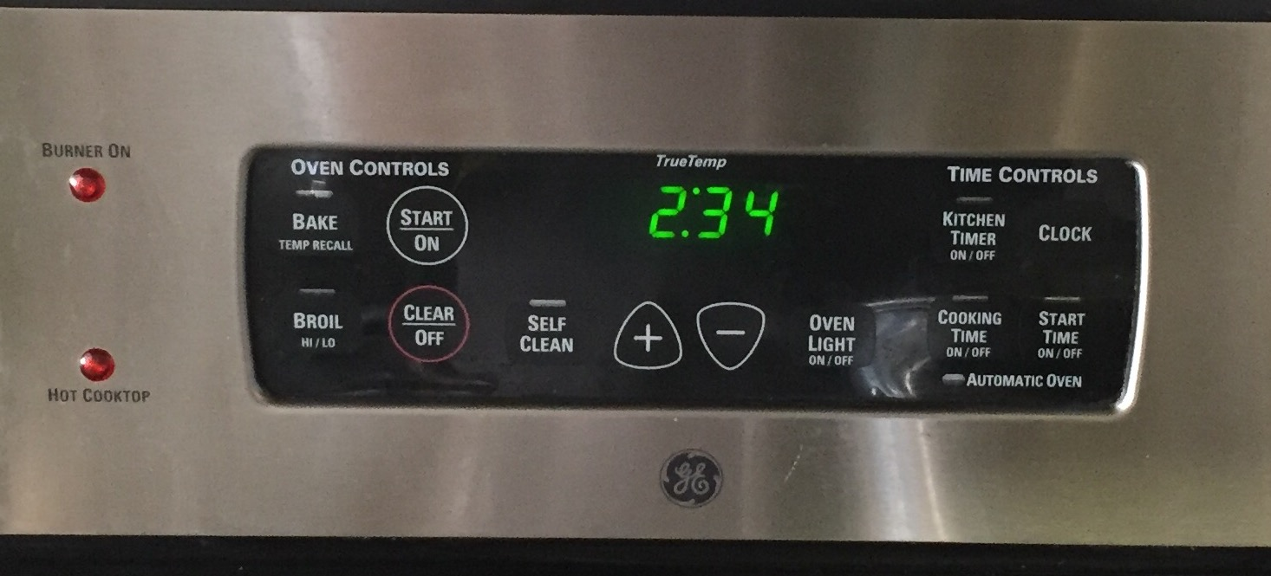

Figure Example of a digital interface with simple functions

### Pro

Having a digital interface on the microwave oven has many advantages than disadvantages.

* Digital interfaces always come with a digital display that allows users to see what temperature has been currently set.
* When the oven is in the pre-heating stage, the digital display displays “PRE” and when the temperature is attained, in addition to the sound, it also displays the current temperature.
* It is to an extant child safe because setting the desired temperature requires two or three buttons to be clicked. In addition to that, the display will let us know if the oven is on or not.
* In addition to all the points above, the digital interface looks sleek and stylish. Since buttons are small and enough to fit the size of the finger, there can be many buttons to do different tasks instead of having each button perform multiple tasks which can be confusing for users.
* Digital interfaces also show the current time in the display when it not in use which is useful. Therefore, it serves a second purpose.

### Cons -

* The exact temperature desired can sometimes be difficult to attain. That is, suppose you want to keep a temperature between 170 degrees and 175 degrees, like 173 degrees. This is because most modern ovens have temperature settings that skip every 5 degrees.

## Smartphone + App Interface –

In both, the analog and digital interfaces, there was one thing that was not possible to do. To switch on and cook food while away from home and to have it ready by the time you return. In our busy lives, sometimes we just do not have the time to return home and cook a healthy meal. So we resort to unhealthy choices. But if we can cook our meal prior to us returning home, there is one hassle out of our minds.

There are new products that are emerging that only use the smartphones to operate the app. These apps using the ‘Internet of Things’ concept and operate the oven even though you are away from home.

### Example of the interface –

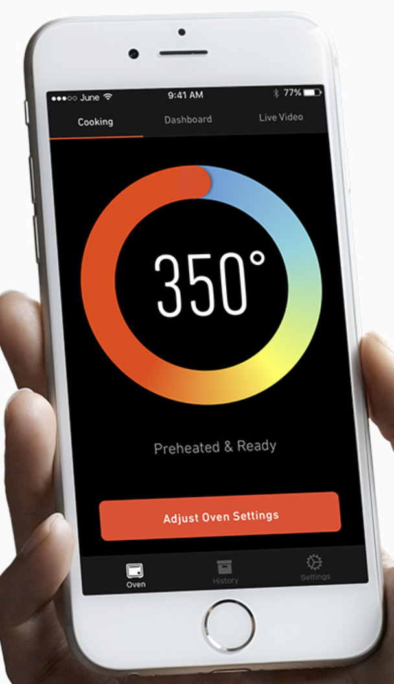

Figure A smartphone application to control oven settings when away from home

The smartphone application in Figure 3 shows a simple interface where users can adjust oven settings. There are different views of the interface. Users can also see live videos of how the food looks from their smartphones. This is extremely useful if you are not at home and want to see how the food is coming along.

### Pros –

* In addition to having the food prepared for you while you leave home, the smartphone can also be used to pre-heat the oven.
* If the interface is easy to use, the smartphone app serves as the best method to operate the oven.
* It can also show notifications about the current temperature, or remaining time, etc.
* Some ovens, like [June](https://juneoven.com/the-oven), can allow users to see real time video of the food being cooked and users can take photos to share it with the social media.

### Cons –

Since smartphones depend on the network to connect to these devices at our home, it can be a serious bottleneck to using the ovens by smartphones.

Though all the interface has their own pros and cons, a combination of digital and smartphone application will be the best and easiest way to operate our conventional ovens.